**SHELL SCRIPT**

**2.A.) BASIC CALCULATOR:**

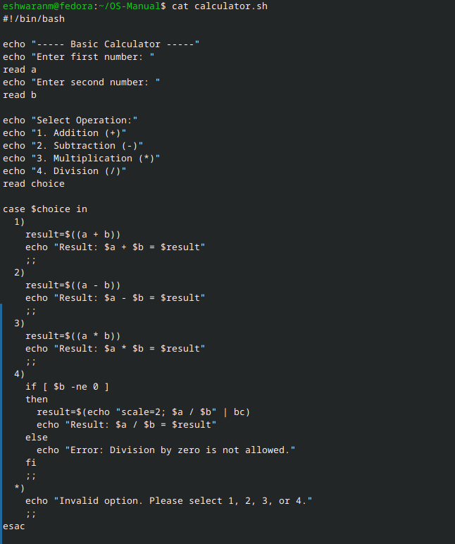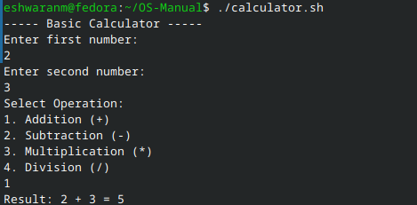

**2.B.) LEAP YEAR**

